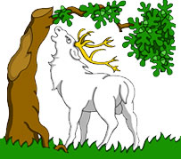 | BERKSHIRE LOCAL HISTORY ASSOCIATION  Registered Charity 1097355  President: Joan Dils
Email: secretary@blha.org.uk
Website: www.blha.org.uk

Executive Committee Agenda
Monday 23rd September 2019 at 19.30
Our Lady of Peace Hall, 338 Wokingham Road, Earley, Reading, RG6 7DA

1. Apologies for Absence

2. Minutes of the Executive Committee Meeting held on 10th June 2019

3. Matters arising not already on the agenda

4. Chairman’s report

5. Treasurer’s Report

6. Journal Editor’s Report

7. Newsletter Editor’s Report

8. Membership Secretary’s Report

9. Web Designer’s Report

10. Awards, Loans and Prizes

11. Projects and Events

12. Annual General Meeting 2020

13. A.O.B.

14. Date of Next Meeting

